Test Case: tc006_SPX_Dev5_Crear_Requisicion_Spot_Tipo_Cobro_Proyect_Urgent
Step 1 - Enter username and password and click to button Enter: Credentials Entered
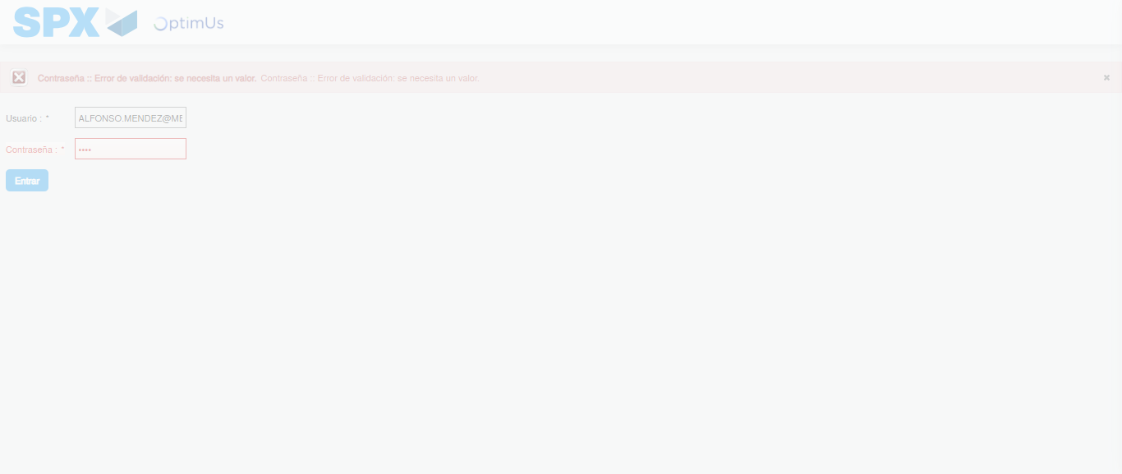Image file-name: QC_Testing-tc006_SPX_Dev5_Crear_Requisicion_Spot_Tipo_Cobro_Proyect_Urgent-1783377392171

Step 2 - Select to UEN and Access to Spot Buy Requisitions : UEN Correctly selected and Correct access
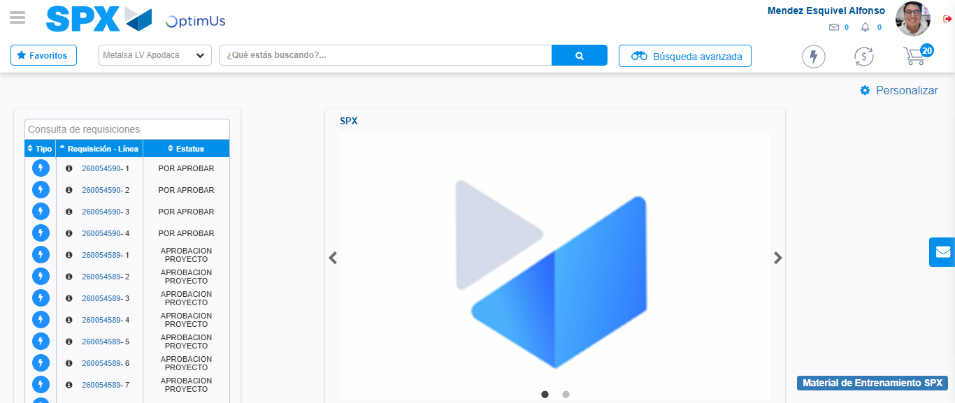Image file-name: QC_Testing-tc006_SPX_Dev5_Crear_Requisicion_Spot_Tipo_Cobro_Proyect_Urgent-1783377417180

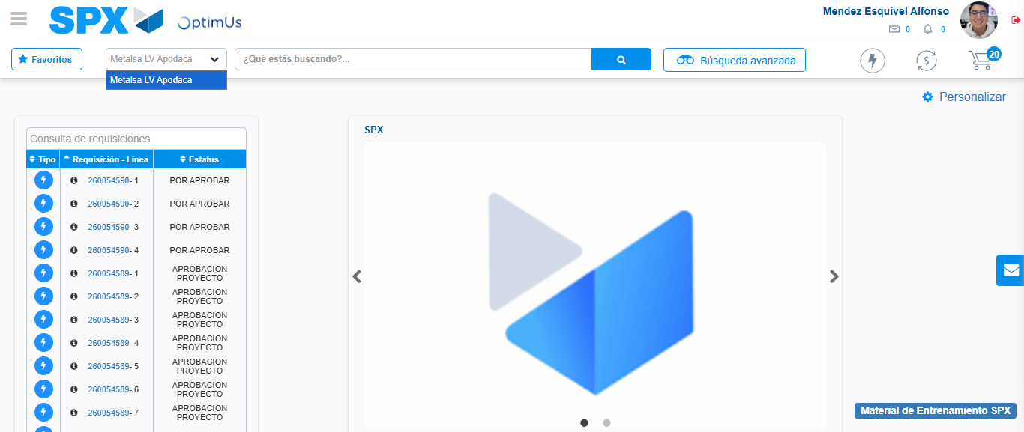Image file-name: QC_Testing-tc006_SPX_Dev5_Crear_Requisicion_Spot_Tipo_Cobro_Proyect_Urgent-1783377419650

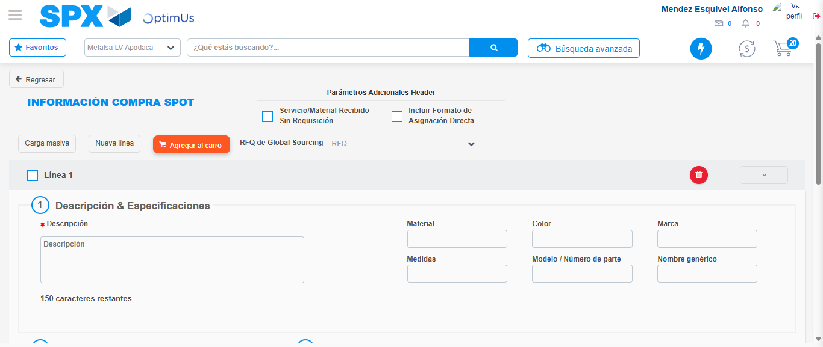Image file-name: QC_Testing-tc006_SPX_Dev5_Crear_Requisicion_Spot_Tipo_Cobro_Proyect_Urgent-1783377438638

Step 3 - Data Capture Spot Buy Requisition: Data captured correctly
Image file-name: QC_Testing-tc006_SPX_Dev5_Crear_Requisicion_Spot_Tipo_Cobro_Proyect_Urgent-1783377438889

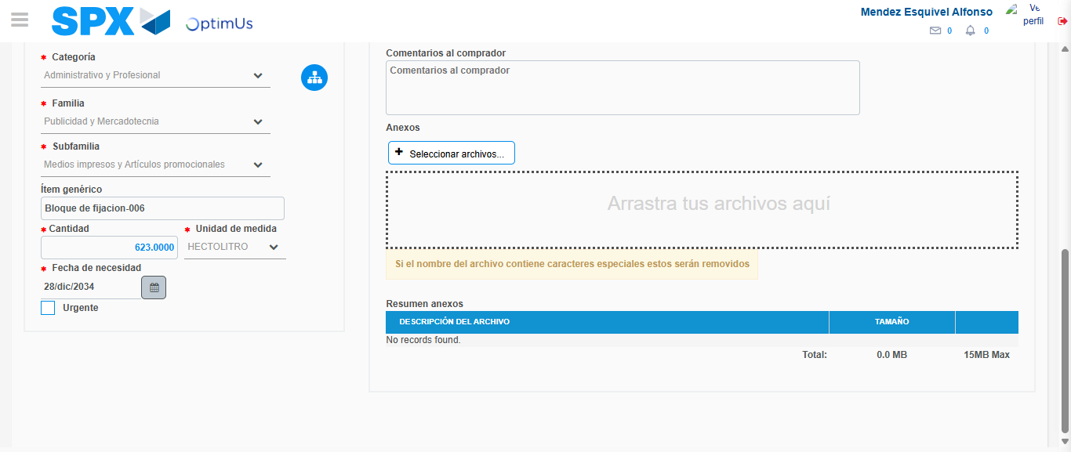Image file-name: QC_Testing-tc006_SPX_Dev5_Crear_Requisicion_Spot_Tipo_Cobro_Proyect_Urgent-1783377449466

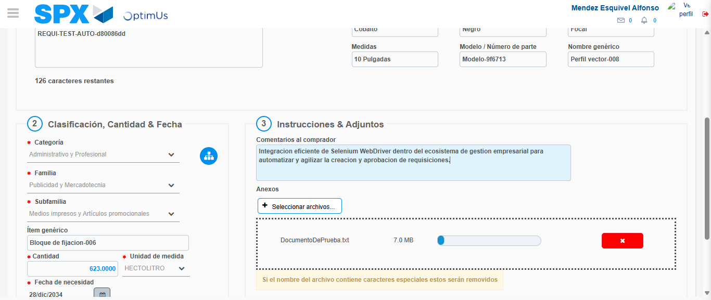Image file-name: QC_Testing-tc006_SPX_Dev5_Crear_Requisicion_Spot_Tipo_Cobro_Proyect_Urgent-1783377450230

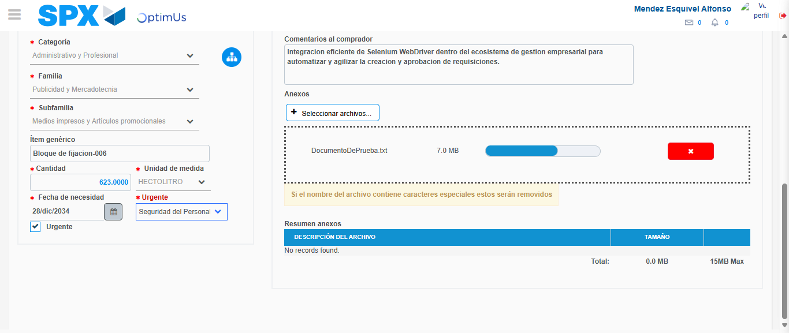Image file-name: QC_Testing-tc006_SPX_Dev5_Crear_Requisicion_Spot_Tipo_Cobro_Proyect_Urgent-1783377453948

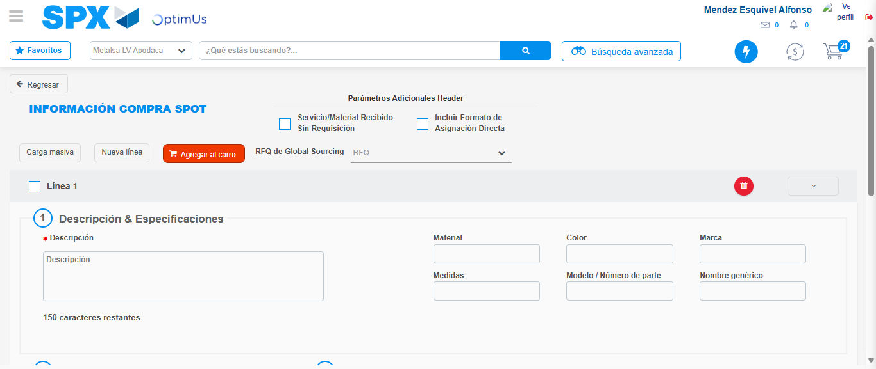Image file-name: QC_Testing-tc006_SPX_Dev5_Crear_Requisicion_Spot_Tipo_Cobro_Proyect_Urgent-1783377460854

Step 7 - Return to Main Page SPX : Return to Main Page SPX
Image file-name: QC_Testing-tc006_SPX_Dev5_Crear_Requisicion_Spot_Tipo_Cobro_Proyect_Urgent-1783377417180

Image file-name: QC_Testing-tc006_SPX_Dev5_Crear_Requisicion_Spot_Tipo_Cobro_Proyect_Urgent-1783377419650

Image file-name: QC_Testing-tc006_SPX_Dev5_Crear_Requisicion_Spot_Tipo_Cobro_Proyect_Urgent-1783377438638

Image file-name: QC_Testing-tc006_SPX_Dev5_Crear_Requisicion_Spot_Tipo_Cobro_Proyect_Urgent-1783377463082

Image file-name: QC_Testing-tc006_SPX_Dev5_Crear_Requisicion_Spot_Tipo_Cobro_Proyect_Urgent-1783377463260

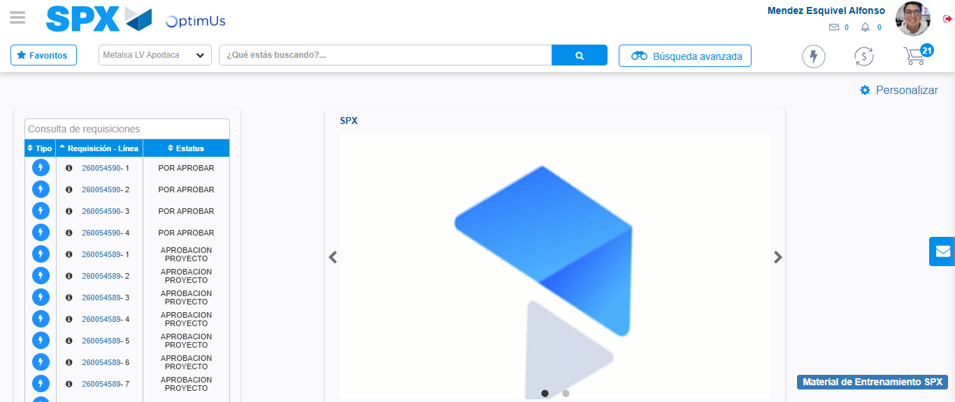Image file-name: QC_Testing-tc006_SPX_Dev5_Crear_Requisicion_Spot_Tipo_Cobro_Proyect_Urgent-1783377484578

Step 8 - Log Out : Log Out SPX
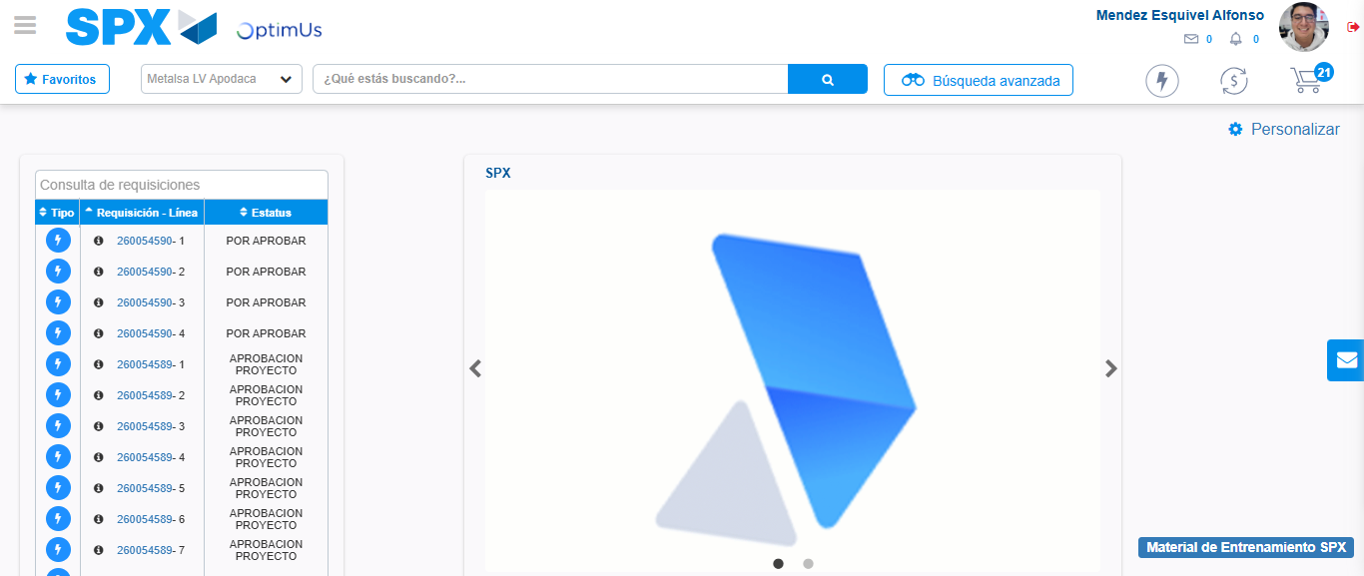Image file-name: QC_Testing-tc006_SPX_Dev5_Crear_Requisicion_Spot_Tipo_Cobro_Proyect_Urgent-1783377484814

